Ans 1.

**SELECT date FROM airbnb_calendar ORDER BY date LIMIT 1;**

**SELECT date FROM airbnb_calendar ORDER BY date DESC LIMIT 1;**

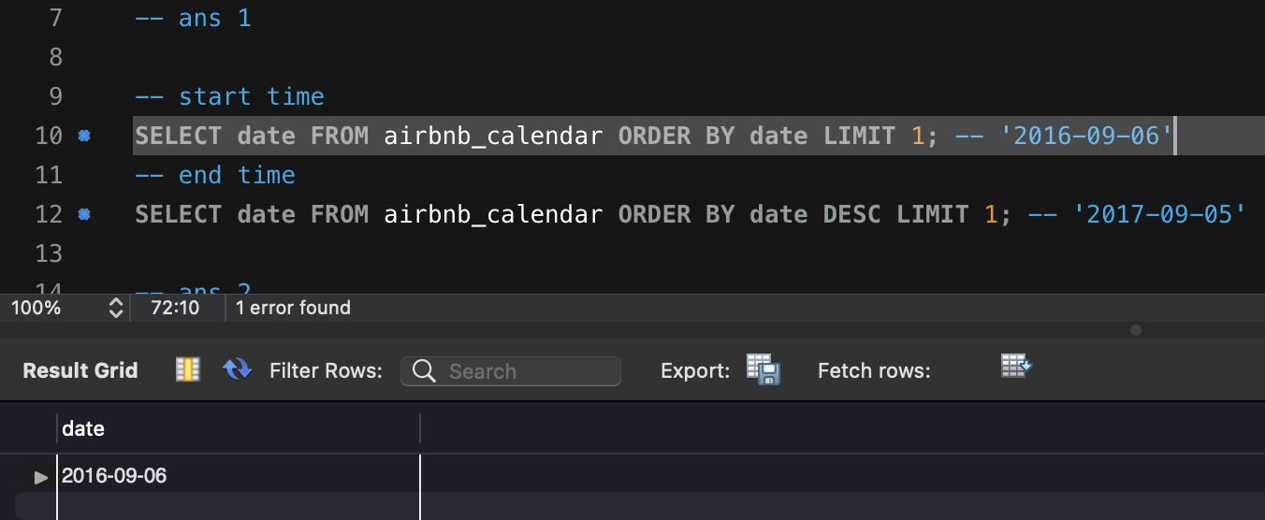

Ans 2.

**SELECT COUNT(DISTINCT listing_id) FROM airbnb_calendar;**

**WITH calendar AS (**

**SELECT ROW_NUMBER() OVER (PARTITION BY listing_id, date, available, price)**

**AS RN FROM airbnb_calendar)**

**DELETE FROM calendar WHERE RN > 1;**

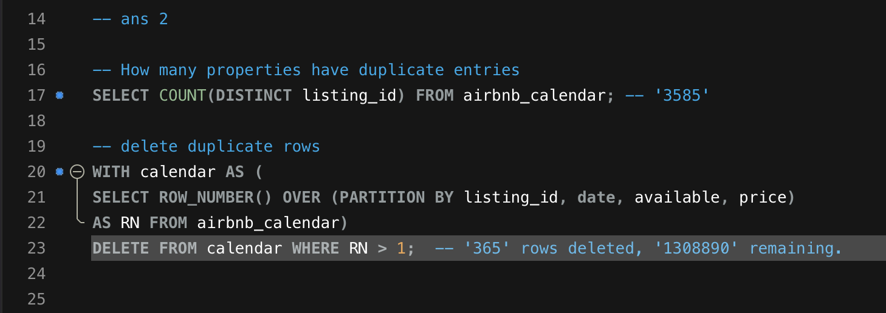

Ans 3.

**SELECT listing_id, SUM(available='t') AS days_available, SUM(available='f')**

**AS days_unavailable, SUM(available='t')/COUNT(*)**

**FROM airbnb_calendar GROUP BY listing_id;**

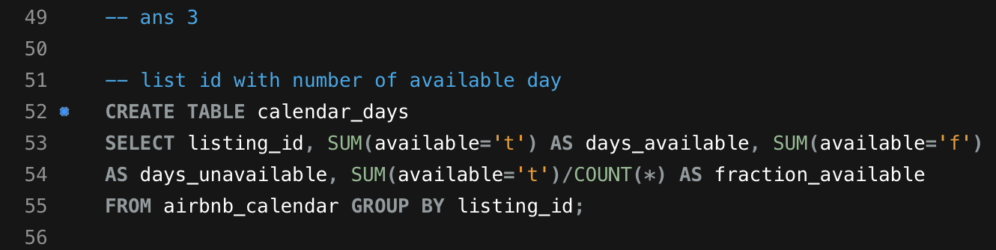

Ans 4.

**SELECT COUNT(*) FROM calendar_days WHERE fraction_available > 0.50; – '1732'**

**SELECT COUNT(*) FROM calendar_days WHERE fraction_available > 0.75; – '1429'**

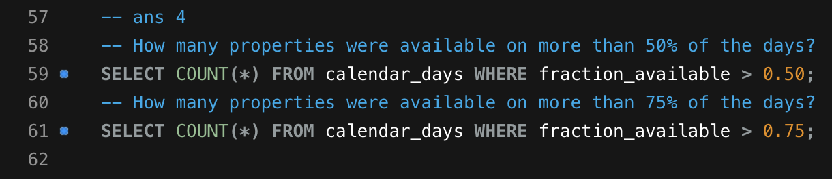

Ans 5.

**CREATE TABLE calendar_prices_helper**

**SELECT listing_id, CAST(SUBSTRING(price,2,10) AS DECIMAL(10,2)) AS prices**

**FROM airbnb_calendar WHERE price!='';**

**CREATE TABLE calendar_prices SELECT listing_id, MAX(prices) AS max,**

**MIN(prices) AS min, ROUND(AVG(prices),2) AS avg**

**FROM calendar_prices_helper GROUP BY listing_id;**

**SELECT listing_id, avg FROM calendar_prices WHERE avg>500;**

